

TurboMeeting User Manual
Version 7.0

RHUB Communications, Inc.
4340 Stevens Creek Blvd.
Suite 282
San Jose, CA 95129
support@rhubcom.com
http://www.rhubcom.com
Contents

Preface 4
Organization 4
Terminology 4
Constraints 5
TurboMeeting Control Panel and Key Functions for Presenter 6
1. Setting up TurboMeeting 7
1.1. TurboMeeting Automatically Upgrades After the Server Is Upgraded 9
2. Hosting an Interactive Meeting 10
3. Joining a Meeting 13
4. Common Features 15
4.1. Audio Conferencing Using Telephone and Computer Audio 15
4.2. Paid Audio Conferencing Option 18
4.3. Pausing, Stopping and Starting Screen Sharing 19
4.4. Changing Application Sharing (Windows only) 20
4.5. Changing Presenter 20
4.6. Changing Controller 21
4.7. Chatting 21
4.8. Sending Files 24
4.9. Recording 26
4.10. Using Webcam 27
4.11. Using Whiteboard 27
4.12. Using Annotation 27
4.13. Floating toolbar 28
4.14. Hide the Attendee List 28
4.15. Disable Recording Function 28
4.16. Report for Each User’s Meetings 28
4.17. Speed Type 29
4.18. Stop Additional Attendees from Joining 29
4.19. Remove Attendees 29
4.20. Request a Participant to Start their Webcam 29
4.21. Make an Attendee a Panelist 30
4.22. Change Language for TurboMeeting UI 30
4.23. Use Google Mail or Yahoo Mail for invitations 31
4.24. Emails and Calendar Events Generated for Invites 31
4.25. Multiple Monitors for Presenter 32
4.26. Multiple Monitors for Supporter 33
4.27. Share Computer Audio with Attendees (Windows Vista or newer) 33
4.28. Polling (Windows hosts only) 33
4.29. Push URL to Attendees 36
4.30. Send Q&A to All Attendees 36
4.31. Show all TurboMeeting Windows 37
4.32. Auto-Uninstall TurboMeeting from Attendee Computers 37
4.33. Show Presenter’s Desktop When Meeting Starts 37
4.34. Remote Printing (Windows only) 37
4.35. Setting Attendees Default Audio Mode 38
4.36. Attendees Optimization for Fastest Speed or Least Bandwidth 38
4.37. Attendees Can Zoom Their View of the Presenter’s Screen 39
4.38. Attendees Can Ask to Become Controller or Presenter 39
5. HD Video Conference 40
5.1. Starting an HD Video Conference 40
5.3. Host Layout Options and Features 40
41
5.3. Telepresence (Windows only) 42
6. Remote Support 44
6.1. Starting a Remote Support Meeting 44
6.2. Inviting the Attendees 44
6.3. Providing Multi-Tier Support 45
6.4. Switching to Training Mode 45
6.5. Rebooting Remote Computer and Auto-Rejoining 45
6.6. Closing Remote Support Session and Locking Computer 46
6.7. Remote Support One-to-One File Transfer 46
7. Webinars 47
7.1. Starting a Webinar 47
7.2. Inviting Attendees 47
7.3. Joining a Webinar 47
7.4. Inviting Meeting Panelists 48
8. Remote Access to This Computer 49
8.1. Starting a Meeting for Remote Access 49
8.2. Remotely Accessing my Computer 50
9. Live Streaming 51
9.1. Starting a Live Stream 51
9.2. Inviting Attendees 51
9.3. Joining a Live Stream 51
9.4. Inviting Meeting Panelists 52
10. Unattended Support 53
11. Scheduling Meetings 57
10.1. Scheduling a Meeting 57
10.2. Editing a Scheduled Meeting 58
10.3. Starting a Scheduled Meeting 58
10.4. Deleting a Scheduled Meeting 58
10.5. Transfer a Scheduled Meeting to a New Host 59
12. Managing your Profile 60
13. Support Contact 61

Preface
TurboMeeting is a multi-function web collaboration system. The client-server architecture requires Internet connectivity for its operation. TurboMeeting has five distinct functions based on these meeting types:
- Interactive Meetings – Give sales presentations, product demos, and collaborate interactively.

- HD Video Conference – Up to 30 webcams based video conferencing with 1080p and telepresence.

- Remote Support – Support PC and Mac users remotely. Mobile clients supported as well.

- Webinars – This function ensures webinars that are easy, fast and reliable to join. You can join without any downloads. VoIP cannot be used in Webinars. Phones must be used.

- Remote Access to Computers – Access your office or home PCs from anywhere, anytime.

- Live Streaming – Stream desktop, HD video and audio to browser-based viewers across all platforms

Depending on the product model you buy, some of the meeting types may not be available to you.

Organization
This manual provides the steps to use the TurboMeeting web collaboration system. The User Manual is organized as follows:

Section 1 | Setting up TurboMeeting
Section 2 | Hosting an Interactive Meeting
Section 3 | Joining a Meeting
Section 4 | Common Features
Section 5 | Remote Support
Section 6 | Webinars
Section 7 | Live streaming
Section 8 | Remote Access to This Computer
Section 9 | Unattended Support
Section 10 | Scheduling Meetings
Section 11 | Managing Profile
Section 12 | Support Contact

Terminology
The following terms are used throughout this manual. In a meeting, a participant can be either the Host or an Attendee:
- The Host is the person who initiates the meeting. The Host must have a user account in TurboMeeting system.
- The Attendee is the person invited by the Host to join a meeting. Attendee does not need an account in TurboMeeting system.

The Host or an attendee can either be:
- The presenter showing their computer to all participants
- A controller controlling the Presenter's keyboard and mouse

Constraints
Here are a couple of constraints:

- There is only one host and one presenter at any moment in a meeting.
- The host or the current presenter can assign any interactive participant to be the presenter.

TurboMeeting Control Panel and Key Functions for Presenter
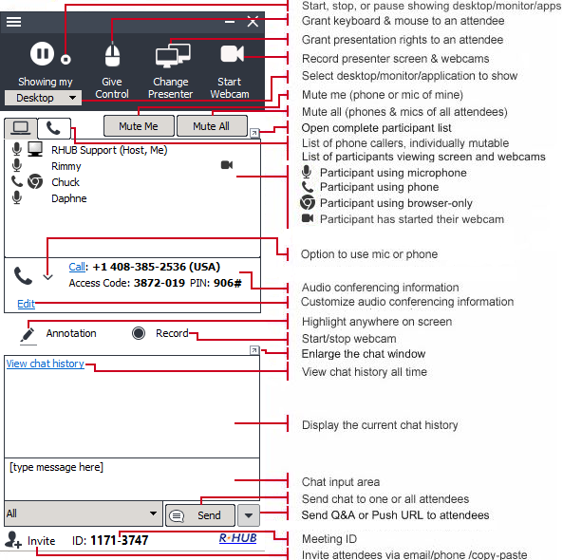TurboMeeting Control Panel for Presenter

Setting up TurboMeeting
To host any type of meeting, you need to download and run the TurboMeeting client.

- In a web browser, go to your meeting server web address:

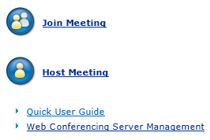

Home Page

- Click the Host Meeting link or icon.
- If the download does not begin, click the “restart the download” link.
- In Firefox, click “Save File” and go to Downloads.
- If Downloads appears, double click “TurboMeetingStarter”
- Click “Run” or “Open”. TurboMeeting downloads, installs and runs on your computer.

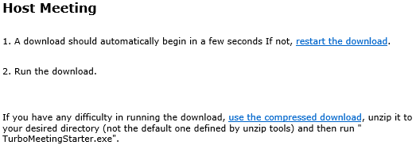

Automatic download

If TurboMeeting does not install and run, click the “use the compressed download” link.
- Extract (or unzip) the files from the resulting zip file.
- Execute the extracted “TurboMeetingStarter” file. TurboMeeting is downloaded, installs and runs on your computer.

After TurboMeeting is installed, you can launch it by clicking the TurboMeeting shortcut on your desktop or via your computer’s Start menu → Programs → TurboMeeting → Start Meeting.

TurboMeeting shortcut

You will have to sign in to host a meeting. Provide the following information:
- Email Address (or Username)
- Password
- Meeting Server Address
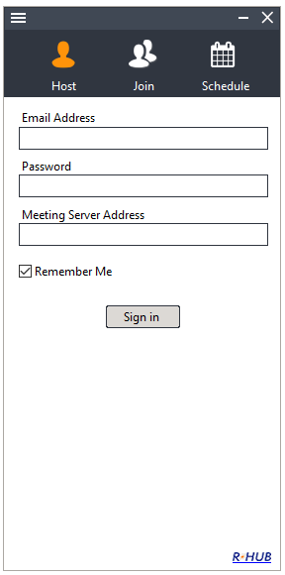
Signing in to host a meeting

TurboMeeting Automatically Upgrades After the Server Is Upgraded

After the RHUB server is upgraded to a new version, a user’s TurboMeeting client will automatically upgrade the next time that user tries to start the TurboMeeting application. This is the dialog that the user will see while automatically upgrading, which should take less than one minute:

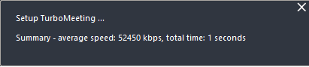
Automatic upgrade dialogs

Hosting an Interactive Meeting
Using the TurboMeeting product, you can host five types of meetings. This section discusses the steps to host an interactive meeting. This meeting type is the conventional method of web conferencing. Each attendee (using either a PC or Mac) can interact in the meeting and can become the Presenter or a Controller. iOS and Android attends can become Controller if they joined by downloading their apps. This meeting type requires that each participant downloads and executes the TurboMeeting client software; however, if the TurboMeeting client does not exist on the participant’s OS, then the participant will join in a web browser.
- Launch TurboMeeting by clicking the TurboMeeting shortcut from the desktop.
TurboMeeting shortcut
- Enter the login credentials and Sign In.
- In the meeting control panel, click the Host icon to host an unscheduled impromptu meeting.
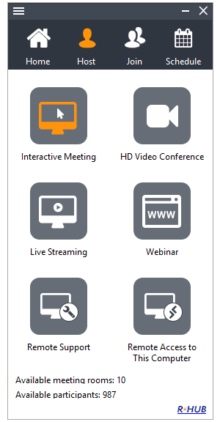
Meeting control panel

- Select the Interactive Meeting type
Please note that as of V7, hosting a meeting no longer gives you the option to input a meeting subject and password! To do so you will need to schedule a recurring meeting. See Section 10.
This screen displays the Attendees, the Meeting Server Address, and the Meeting ID.

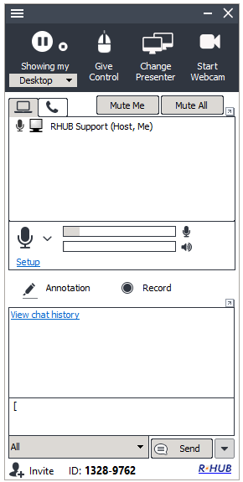

Meeting screen
You can now invite attendees to join the meeting. To invite attendees:
- Click the Invite button
- Click the Email button to email the steps to the invitees or click Copy and paste the details to the attendees via online messaging tools or web-based email clients.

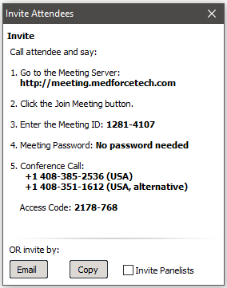

Invite attendees

Joining a Meeting
When you receive an invite from the host, open your browser and
- In the browser’s address bar, enter the meeting server’s address
- Click the Join Meeting icon.
- Fill in the Meeting ID, Meeting Password (if any) and Your Name.
- Click the Join Meeting button.

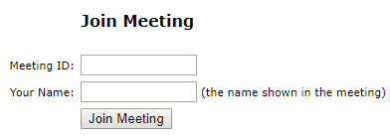

Joining a meeting

- If the meeting is a webinar, which does not require any download, you join the meeting.
- If the meeting is not a webinar, the TurboMeeting application automatically launches if it is installed or the TurboMeetingStarter.exe or MACStarter downloads.
- If the download does not begin, click the “restart the download” link.
- In Firefox, click “Save File” and go to Downloads.
- If Downloads appears, double click “TurboMeetingStarter” or “MACStarter”.
- Click “Run” or “Open”. TurboMeeting downloads, installs and runs on your computer and you will automatically join the meeting.

If you have already installed the TurboMeeting client, you can join a meeting with these steps:
- Launch TurboMeeting by clicking the TurboMeeting shortcut from the desktop.
- Click the Join button.


Option to join a meeting
- Enter the Meeting ID, Meeting Password (if required), Your Name, and the Meeting Server Address.
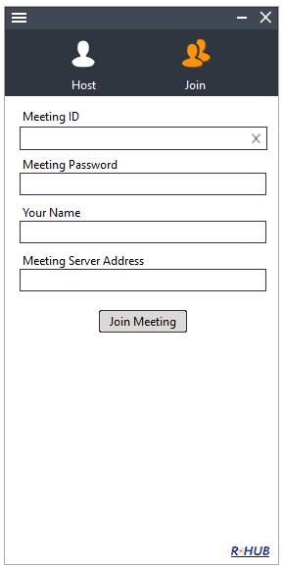
Details required while joining a meeting

- Click the Join Meeting button.

Common Features
There are many features that are common to all four types of meetings. This section discusses the common features.

Audio Conferencing Using Telephone and Computer Audio
Starting with the 5.0 release and on, the conference call telephone and computer audio are integrated together. Thus, each attendee can choose whether they listen and talk on the phone or by using a headset on their computer.
The host of the meeting must start the meeting in TurboMeeting before the conference call can begin, unless the paid audio conferencing service is used.
An attendee can choose “Use Telephone” then call in with the provided phone number and Access Code. Or an attendee can choose “Use Mic & Speakers” VoIP computer audio. When using computer audio, a headset is strongly recommended since built-in speaker sound used by any one participant can generate echo for the other participants:
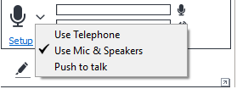
Audio Modes, Volume meters, and Speaking indicator
If “Use Mic & Speakers” is chosen, a participant can click Setup to change the volume of their speakers or microphone or to change which device should be used as their speakers or microphone. It is best to setup and test new headsets before joining a meeting.
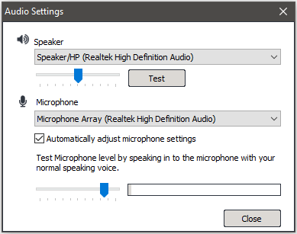
VoIP Computer Audio Setup dialog
The Push & Hold to Talk function is activated when more than five possible talkers appear in a meeting (five is the default setting that can be changed by the administrator). When the Push & Hold to Talk button is present, the attendee must click and hold the Push & Hold to Talk icon to be heard.
Push & Hold to Talk button

An attendee can also have the Push & Hold to Talk icon if the host pushes the right mouse button on the attendee’s name in the Attendees list and chooses Change to push-to-talk for that attendee. Then, the host can undo this setting by pushing the right mouse button on the attendee’s name and choosing Change to free-to-talk.

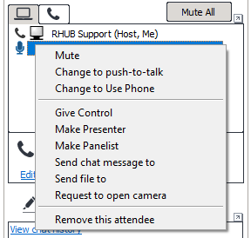
Host right clicks attendee. Mute and Push-to-talk available
The host can also mute individual attendee’s by pushing the right mouse button on an attendee’s name in the Attendees list and choosing Mute. The host can mute all attendees, both on the telephone and on the computer, by clicking the Mute All button.
Host’s ‘Mute All’ attendees button
The host can minimize background noise and echo by selectively choosing any or all attendees and muting them or by individually forcing attendee’s into Push-to-Talk mode.

Each attendee (and host) can mute themselves by clicking the Mute Me button or by pushing the right mouse button on their name in the Attendee list and choosing Mute Me.
Attendee’s ‘Mute Me’ button
The host can right mouse on each attendee’s name in the Attendees list and change their mode of communication by choosing Change to Use Phone or Change to Use Mic .

There is a telephone tab which shows everybody who has dialed into the Conference Call number. A PIN number is provided to all attendee’s who join the online meeting. If an attendee enters this optional PIN number, then their name will appear in the telephone tab instead of a telephone number; and their name will also appear in the Speaking list, thus making it easier to determine who is talking during a meeting. In the telephone tab, the host can right mouse on a caller’s name or phone number and Mute or Unmute them.

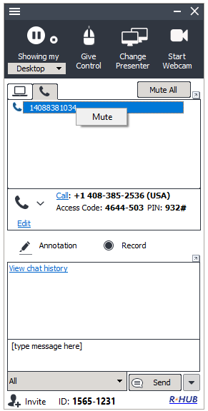
Telephone tab and Speaking list

People who use the Conference Call number have two commands they can enter on their telephone’s keypad:

*2 - Raise Hand (can’t toggle off)
*6 - Mute yourself (toggle on and off)

Paid Audio Conferencing Option

When starting or scheduling a meeting, the host can choose to use paid or free audio conferencing services. Paid audio conferencing requires a subscription and must be established in advance of any meetings requiring it. Paid audio conferencing services offer toll-free numbers and dial-in numbers in more countries. Participants can join a paid audio conferencing session by dialing any of the phone numbers which are currently provided in 27 countries (check the current list of countries with phone numbers at http://www.rhubcom.com/v4/web_conferencing/paid_audio_conferencing.html). Unlike free services, paid services allow the host to start an audio conferencing session anytime without starting the associated online meeting.

The meeting host chooses to use the paid or the free audio conferencing service by getting in contact with the Rhub Support staff. Email is support@rhubcom.com and phone line is +1 408 899 2830 x2. Office hours are Monday – Friday 9:30AM – 6PM PDT

With paid audio conferencing, the system generates a unique access code which allows the host to start a standalone audio conferencing session. Click "Invite" and then "Show it" to see the host's access code. This “Show it” link is the only place where the host’s access code is exposed. Email invitations and all other parts of TurboMeeting only show the attendee’s access code.

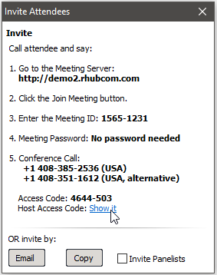
The hidden host’s access code for a paid audio conference

Note that anyone with the host’s access code can start a standalone audio session, and the host's employer is obligated to pay for the costs. Therefore, it is important to keep the host's access code secret. If the access code is compromised, delete the scheduled meeting that the access code is associated with. One host access code is associated with only one meeting ID.

If you as the host want another trusted conference participant to continue hosting the session while you leave the session, you can share your host access code with that participant. One audio conferencing session can have multiple hosts. The session continues as long as there is one phone host or an online meeting host.

Unlike for paid audio conferencing, free audio conferencing only has one access code: hosts and attendees must enter the exact same access code.

Pausing, Stopping and Starting Screen Sharing

When you start a meeting, by default, your desktop will be shown to meeting attendees. The pause icon indicates that your screen is being shown.
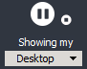
Icon indicating active application sharing

To pause showing your screen, click the Pause button. The Pause button becomes a Play button and the word Paused indicates that the meeting has been paused. Existing attendees will continue to see a snapshot of your screen at the time you clicked the Pause button.
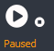
Icon indicating that application sharing is paused
To start showing your screen, click the Play button.
To stop showing your screen and display meeting information for your attendees, click the Stop button. The Stop button becomes a Play button and the word Stopped indicates that the meeting has been temporarily stopped. To start showing your screen, click the Play button.

Icon indicating that application sharing is temporarily stopped
The attendees will see the following screen while the meeting is Stopped:
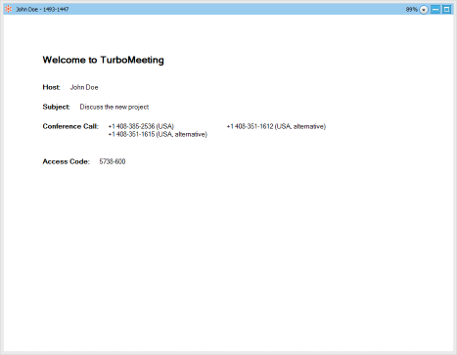
Attendees see this screen after the presenter has clicked the Stop button

Changing Application Sharing (Windows only)
By default, the primary monitor is shown to the meeting attendees. The Showing My drop-down list displays all the applications open on your system. To show another application, click the Showing My drop-down and choose a running application. Both Windows and Macs allow you to choose to share an individual monitor from this list.
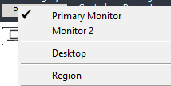
Option to change application sharing

Changing Presenter
The attendees who have joined the interactive meeting can also be the presenter to show his or her computer screen to meeting participants. By default, the host will be the presenter. However, during a meeting the host and the current presenter can assign any participant to be the presenter. To change the presenter, click Change Presenter and choose the presenter from the list, or right mouse on the participant’s name in the Attendees list and choose Make Presenter.

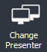
Change Presenter options: Change Presenter button or right mouse “Make Presenter” option

Changing Controller
During the meeting, you as the presenter can assign a participant as the controller. A controller is the person who can control your mouse and keyboard.
To change the controller, click Give Control and choose the participant you want to control from the list, or right mouse on the participant’s name in the Attendees list and choose Give Control.

Give Control option
Click Change Controller then Reclaim Controller to reclaim control from the specified controller.

Chatting
While convening a meeting you can also chat with attendees. To chat with individuals, click the drop-down arrow and choose their name, or you can chat with All attendees. Enter your chat message where it says [type message here] then hit the Enter key or the Send button.
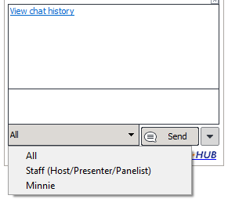
Chat section of TurboMeeting control panel

Your entire chat dialogue for this meeting is shown in the TurboMeeting control panel:
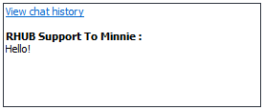
Chat dialogue for this meeting

You can expand the Chat dialogue into a separate, resizable window by clicking the button just above the Chat dialogue:
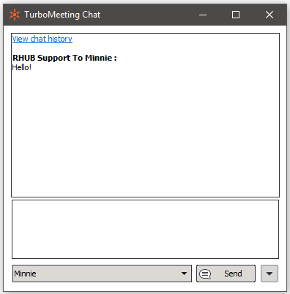
Chat dialogue for this meeting

The View chat history feature shows your entire chat dialogues for all of your meetings:
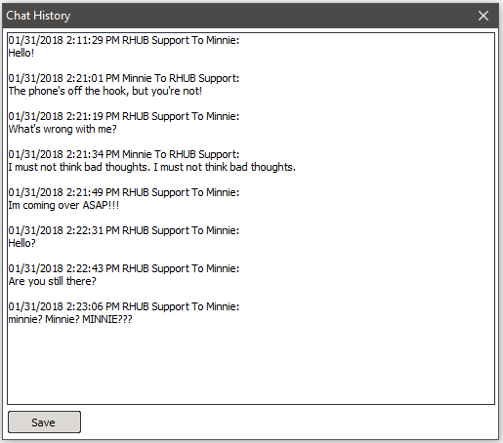
Chat dialogue for this meeting

Sending Files
During a meeting, there may be a need to send files between meeting participants. Instead of opening an e-mail client and sending files, a participant can send files using TurboMeeting. To send files:
- Click the menu item Tools | Send Files to open the File Transfer dialog box.
- Click Add Files/Folders.
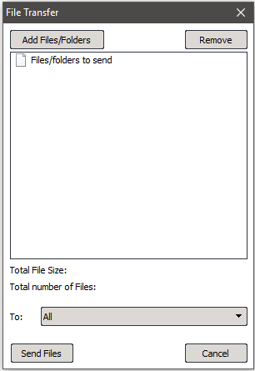

File Transfer dialog

- Select a particular file or folder from the drop-down list. The file or all the folders and files in that directory are displayed.
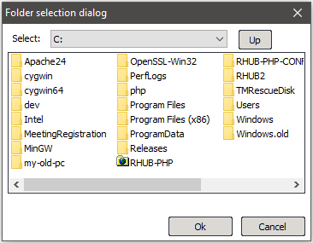
Folder selection dialog
- Select the files, folders, or both and click OK. They are added to the list of files/folders to be sent.
- In the File Transfer dialog, click the drop down-arrow next to the To label, and then select the participants to whom the files should be sent. By default, the files are sent to all other participants.
- Click Send Files.

Recording
During a meeting, you can record the actions on the presenter’s screen and you can optionally record the webcams being shown. If the Audio Conference settings in your RHUB appliance and your meeting are using the “RHUB integrated free audio conferencing service”, then all audio heard in the meeting including phone participants will be recorded.
This paragraph explains how audio gets recorded if you are using your own audio conferencing service (not the “RHUB integrated free audio conferencing service”). If VoIP audio is used, the voices of all TurboMeeting attendees are recorded automatically. If VoIP is not used, the recording captures sounds via the computer’s microphone; therefore, to record the meeting conversation, you need to turn on your speaker phone and move it close to the microphone on the computer doing the recording in order to capture conversations.
Click the record button to start recording and click it again to stop recording. When stopping the recording, the system automatically saves the recording file on your desktop. The file is an executable. Just run the file and it will replay the entire recording session. There is a 2 GB size limit for recordings, which should give you several hours of recording time depending on what is happening on the presenter’s screen.
A recording converter tool is available that allows you to convert TurboMeeting recordings from their proprietary format into the MP4 format. You will need to host the converted recordings yourself.
http://www.rhubcom.com/v5/download-converter-mp4.html
If you have a Mac recording, you will need to transfer the recording to a Windows system in order to convert it. Once the recording is on Windows, find the *.REC file (likely in Contents\Resources\1000.rec ) and convert the *.REC file on Windows.
You can disable the recording of webcams by going to the menu item Tools | Preferences, then Recording, then choose “disable video recording to save size”. Disabling video recording should greatly reduce the size of your recordings
You can slightly increase the length of time available for recordings or improve the quality of recordings by going to the menu item Tools | Preferences, then Recording, then change the “Record frame rate (frames per second)” setting. A setting of “1” gives you the longest possible recording time. A setting of “24” gives you the highest number of frames per second in your recording.

Using Webcam
During an HD Video Conference meeting, up to 30 participants can start their web cameras, or webcams. Each participant’s webcam video will be visible to all attendees. Starting with the 6.1 release and on, when a participant makes a recording, webcams are recorded in addition to the presenter’s screen and any voices in the meeting.
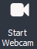
WebCam option

Using Whiteboard
While making the presentation you might have to illustrate some points. The Whiteboard option in TurboMeeting is used for this purpose. Click the three lines icon in the top left corner and select Whiteboard and the Paint application opens, where you can illustrate certain points or draw diagrams.

Using Annotation
Using the Annotation feature you can highlight topics in your presentation. Click the Annotation button and choose the type of annotation from Pen, Highlighter, Spot and Arrow. Then, emphasize the interesting area using the mouse pointer.

When the annotation option is active and the Cursor is not selected, normal keyboard and mouse input ceases and essentially your computer screen freezes. To unfreeze your computer screen, hit the “Esc” key or click the Cursor button.
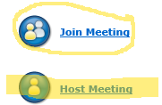
Annotation Pen and Marker used to add emphasis
When the Presenter clicks the annotation button, the annotation toolbar appears.

The features include:
Cursor – when selected, the cursor feature allows the presenter to use. The presenter can use it to change which application is being shown.
Pen – clicking Pen brings up this chooser: which allows you draw free hand, draw a line with an arrow, and draw a straight line.
Marker or Highlighter – allows you to highlight items or text on your screen.
Pointer – allows you to drop a red pointer or dot on the screen.
Eraser – allows you to erase parts of the annotation.
Color picker – allows you to change the color and size of your Pen and Marker.
Shows additional annotation features including “Attendees can draw”, which gives all attendees the ability to annotate at the same time including Windows, Mac, iOS and Android app users. Each user is assigned a different color for annotating. “Panelists can draw” lets your chosen panelists be able to annotate. “Save Annotation” automatically saves the annotation on your desktop. “Erase All” erases all of the annotation that you and everybody else has drawn.

Floating toolbar
The floating toolbar has the advantage of using very little of the presenter’s screen space during a presentation while still providing buttons for the most common features including pausing/showing your screen, starting/stopping your webcam, annotation, microphone muting/unmuting, and chat that changes color when a chat message is received. Just hover your mouse over the overlay to pull down the floating tool bar.
Hover your mouse over this overlay to pull down the floating toolbar

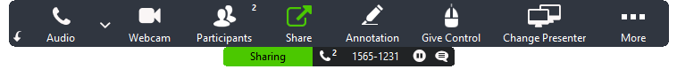
Floating toolbar

Hide the Attendee List
As the meeting host, you can hide the attendee list from your attendees. Click the menu item (three lines icon) then “Preferences”. Under “General", uncheck “Attendees can view attendee list” and click Save.

Disable Recording Function
As the meeting host, you can disable recording functions so that none of the attendees can record the meeting session. Click the menu item (three lines icon) then “Preferences”. Under “Recording”, uncheck “Attendees can Record” and click Save.

Report for Each User’s Meetings
Each meeting host can get a list of their past meetings by starting a new TurboMeeting session and clicking the menu item (three lines icon) then “Report”.

Speed Type
There are three internet speed type options available in TurboMeeting that let you choose the frames per second at which attendees see the host:
- Low Speed (Worst)
- Fast Speed
- Turbo Speed (Best)
The speed type that the host has selected is the speed type that all attendees will see when viewing the presenter’s screen. If an attendee has a speed that is lower than the host’s chosen speed type, the lower speed type overrides the higher one and the attendee will see the presenter’s screen at the lower speed type. The same does not apply for higher speed types. If an attendee has a higher speed type than the host’s speed type, he will still view the presenter’s screen at the lower speed. To change the speed type, choose the menu item (three lines icon) then “Preferences”. Under “Desktop Sharing”, choose the “Speed Type” option. Default speed is set in the server management console.

Stop Additional Attendees from Joining
As the meeting presenter, you can stop any further attendees from joining the meeting. Click the menu item (three lines icon) then select “Stop new attendees from joining”.

Remove Attendees
As the meeting host, you can remove attendees from the meeting. In the Attendees list, right click the attendee’s name and choose “Remove this attendee”.

Request a Participant to Start their Webcam
As the meeting presenter, you can right click a participant’s name and choose “Request to open camera”. The participant will be provided with a dialog asking them to start (one of) their webcam(s).

Make an Attendee a Panelist
A “panelist” in a meeting can aid the presenter by receiving and responding to chats.
The host can make an attendee a participant by right mousing on the attendee’s name in the Attendees list and choosing “Make Panelist”. Or the host can invite panelists before the meeting starts by selecting the “Invite Panelists” check box in the Invite Attendees dialog.
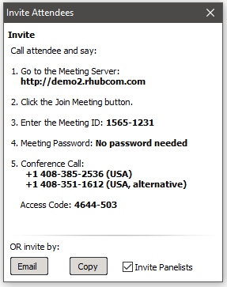

Change Language for TurboMeeting UI
Each TurboMeeting user can change the language of their TurboMeeting user interface. Click the menu item (three lines icon) then “Preferences”. In “General” select a language from the drop-down list.
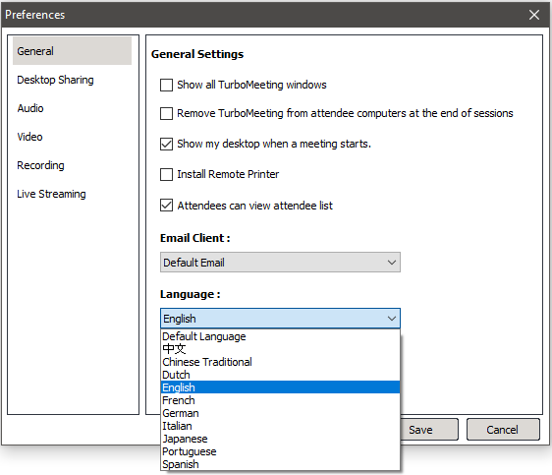

Language setting

Use Google Mail or Yahoo Mail for invitations
Each user can use either Google Mail or Yahoo Mail as the default email system to use when TurboMeeting generates an e-mail invitation. Click the menu item (three lines icon) then “Preferences”. In “General” select your preferred Email Client from the drop-down list. The user needs to be logged into Google Mail or Yahoo Mail for the email invitation to be successfully generated.

Emails and Calendar Events Generated for Invites
Calendar events for Outlook, Mac Mail, etc. are automatically generated when a TurboMeeting user schedules a meeting. And an email can be generated when a user chooses to invite attendees to an active meeting.
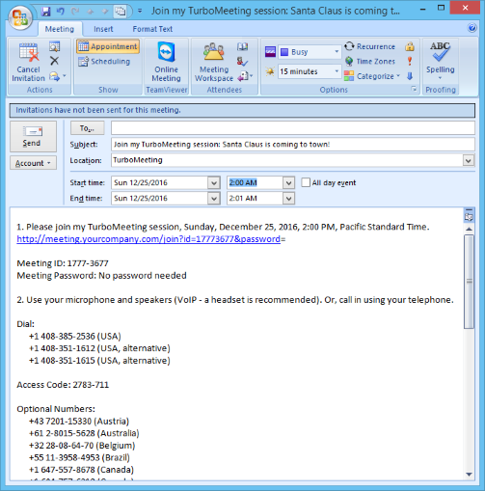
Outlook message with calendar information is automatically generated for a scheduled meeting

Multiple Monitors for Presenter
If a meeting presenter has multiple monitors, the presenter can choose to display a specific monitor or the entire desktop, which is composed of more than one monitor.

Multiple Monitor selection in TurboMeeting
Below is the view that attendees would see for a presenter that has multiple monitors when the entire Desktop is displayed:
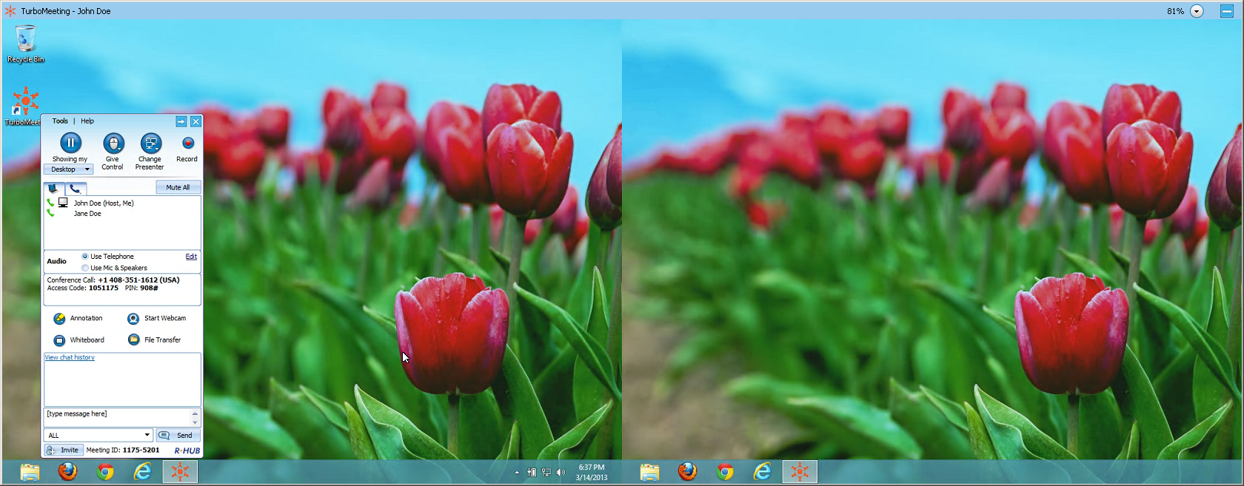
Multiple Monitor view if entire Desktop shown

Multiple Monitors for Supporter
A person that is providing Remote Support to a computer with multiple monitors is given the option in TurboMeeting to show the entire Desktop or to show individual monitors as shown below:
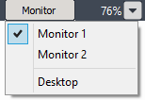
Remote supporter can view entire Desktop or individual monitors

Share Computer Audio with Attendees (Windows Vista or newer)
In Windows Vista and newer Windows operating systems (including Windows 7, Windows 8 and Window 10), the presenter in a meeting can start sharing their computer’s audio with their attendees by clicking the menu item (three lines icon), then choosing “Start to share my computer sound with attendees” option. When this feature is enabled, the presenter can play a video that gets shared with their attendees and stream the video’s audio to their attendees. For this feature to work, at least one of the participants in the meeting needs to choose the “Use Mic & Speakers” option.

Polling (Windows hosts only)
The host of a meeting on Windows can create a poll with questions and multiple choice answers for the attendees. Poll questions can be created ahead of time by clicking the Poll link in the user’s list of scheduled meetings. Or the host can create a poll question during the meeting by clicking the menu item (three lines icon), then the “Poll” option.

Each poll question can have up to five pre-determined answers. The poll can limit the attendees to voting for just one response or allow the attendees to vote for multiple responses.
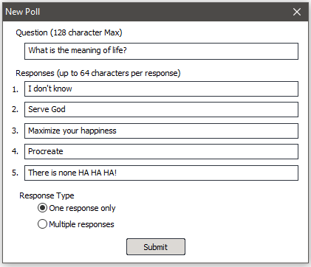
Interface for creating a new Poll
After the poll question is created, the host can begin polling the TurboMeeting attendees for responses. Windows, Mac and Flash (browser) attendees can take part in polls. The attendees will see a window similar to this:

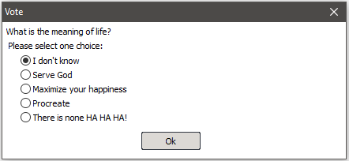
Attendees voting window
The poll stays open until the host decides to close polling. Once the poll is closed, the results are tabulated for each answer. The poll is blind: there is no way to determine how each attendee voted.
The host’s “Manage Poll” window provides a Close Polling link. (A Start Polling link initially appears where Close Polling appears below).
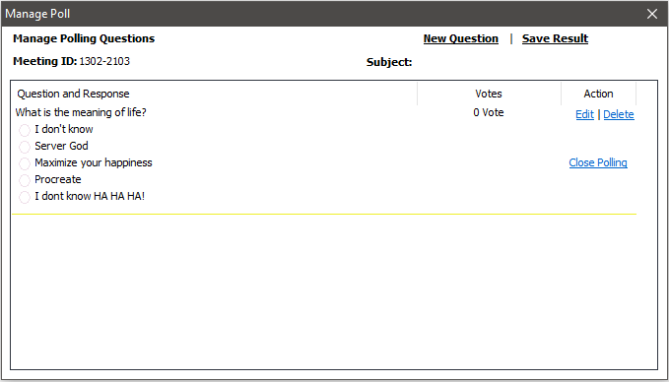
The host’s “Manage Poll” Interface
After the host closes the polling, the host sees a Share link where the Close Polling link used to be. When the host clicks the Share link, the attendees see a window with the polling results. Finally, the host can click the Share link to close each attendee’s “Polling result” window.
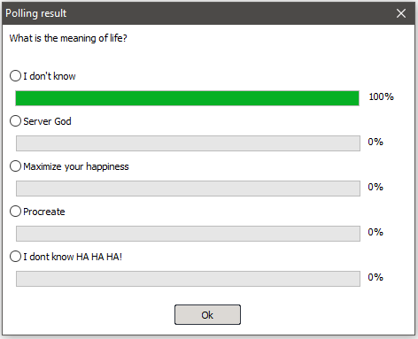
The attendee’s “Polling result” window

Push URL to Attendees
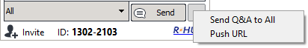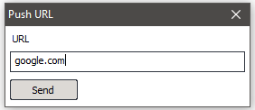
“Send Q&A to All” and “Push URL” options
The presenter can push an URL or web page that opens up in a browser on each attendee’s computer or device providing that the attendees have joined interactively. The circular button on the bottom right of the control panel contains the “Push URL” feature.

Send Q&A to All Attendees
The presenter can send a question and answer to their attendees. The attendees see the question and answer in their chat window. The circular button on the bottom right of the control panel contains the “Send Q&A to All” feature.

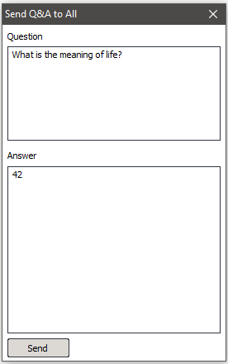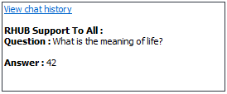
“Send Q&A to All” and attendee’s view of Question and Answer in their chat window

Show all TurboMeeting Windows
As the meeting presenter, you can display all transparent windows on your screen. By default, attendees cannot see the host’s TurboMeeting and its associated windows since these windows are treated as transparent. To expose the TurboMeeting control panel and associated windows, click the menu item (three lines icon) then “Preferences” and under “General” check “Show all TurboMeeting windows” and click Save.
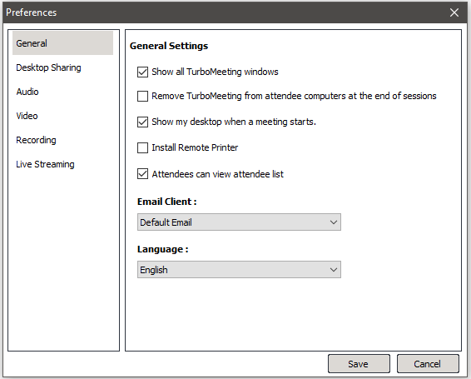
General settings

Auto-Uninstall TurboMeeting from Attendee Computers
As the meeting host, you can tell the system to automatically uninstall the TurboMeeting client on the attendee computers at the end of a meeting session. Click the menu item (three lines icon) then “Preferences” and check “Remove TurboMeeting from attendee computers at the end of sessions” and click Save.

Show Presenter’s Desktop When Meeting Starts
As the meeting host, you can start every meeting in a Paused state by clicking the menu item (three lines icon) then “Preferences” and un-check “Show my desktop when a meeting starts” and clicking Save.

Remote Printing (Windows only)
Remote printing is the ability to print directly from the host’s Windows computer to a printer of the attendee’s choice on the attendee’s network. This is useful if the host is printing from an application that is not installed on the attendee’s computer. To enable printing to an attendee’s printer, click the menu item (three lines icon) then “Preferences”, check “Install Remote Printer” and click Save. Then, open the file to print and select Print. Choose the TurboMeeting Printer and click OK. The print job automatically gets transferred to your attendee’s computer, and as with a normal print job, your attendee uses their Print interface to decide where to print it.
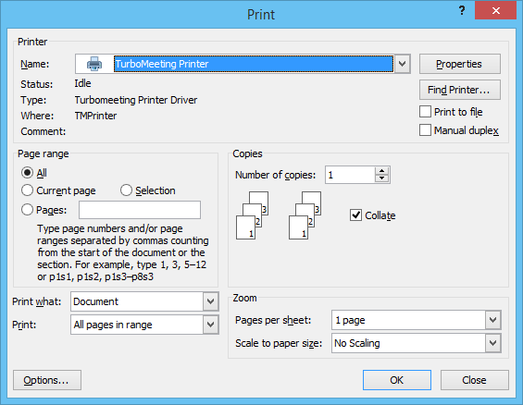
Choose TurboMeeting Printer to send print job to attendee’s Print interface

Setting Attendees Default Audio Mode
As the meeting host, you can set the initial audio mode of your attendees by going to the menu item (three lines icon) then “Preferences” and under “Audio” change the value of “Default attendee audio mode” to “Use system default”, “Use computer mic & speakers” or “Use Telephone”. If an attendee changes this setting, the attendee will use their newly saved setting in the future.

Attendees Optimization for Fastest Speed or Least Bandwidth
An attendee can optimize their viewing experience for receiving screen updates by using the fastest speed by using the least amount of bandwidth (which can improve the stability of screen updates). The attendee can change his setting by going to the menu item (three lines icon) then “Preferences” and under “Desktop Sharing” change the value for “Optimization” to “Fastest Speed” or “Least bandwidth & best stability”.

Attendees Can Zoom Their View of the Presenter’s Screen
A TurboMeeting attendee can zoom in or out their view of the presenter’s screen to set percentages anywhere between 50% and 400%. By default, the zoom is set to “Fit to Screen up to 100%”. “Fit to Screen” makes the viewer window as wide or as tall as the monitor will allow the viewer window to be. If the attendee chooses either of the “Fit to Screen” options, then the viewer window is full-resizable by dragging one of the windows corners.
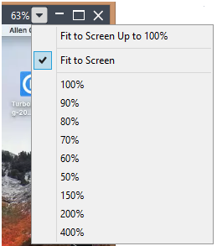
Attendee can zoom in our out of their view

Attendees Can Ask to Become Controller or Presenter
A TurboMeeting attendee can ask the current presenter if they can control the presenter’s screen or if they can become the new presenter. Both “Request to control the presenter screen” and “Request to present my desktop” are in the attendee’s menu item (three lines icon).
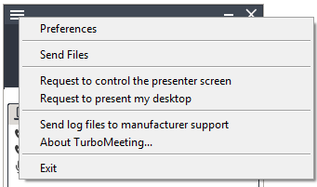
Attendee can ask to become controller or presenter

HD Video Conference
This function allows the participants to take part in a video conference with up to 30 webcams. A participant with multiple monitor can enable telepresence which allows that participant to distribute the webcams, and possibly screen sharing, across their monitors.

Starting an HD Video Conference
- Launch TurboMeeting by clicking the TurboMeeting shortcut from the desktop
- Enter the login credentials and Sign In.
- Click the Host icon to host an impromptu support meeting.
- In the next step, choose the HD Video Conference meeting type.

Host Layout Options and Features
The host can enter HD Video Conferencing mode by starting an “HD Video Conference” meeting or by clicking the HD button in the webcam window during an “Interactive” meeting. During HD Video Conference mode, up to 30 TurboMeeting attendees can display the video from their webcams by clicking the “Start Webcam” button.
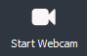

Multi-Party video conference with up to 30 attendees’ webcams
From the HD Video Conference interface, the host controls the layout of the webcams that the attendees see, can invite attendees, can stop individual webcams and can make someone the spotlight webcam. The controls in the upper right hand corner mean the following:
Switch to sharing your desktop mode instead of HD Video Conferencing mode
Spotlight webcam is full-screen while other webcams are on the right
Spotlight webcam is full-screen while other webcams are on the bottom
Spotlight webcam on top with other webcams on the bottom
All webcams are equally sized as shown in the above screen capture
Toggles between Maximizing the webcam window and Restoring Down from maximized. Each participant has this control allowing them to control the size of their webcam views.
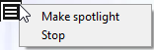
The host can click the button in the upper left corner of each webcam. It allows the host to stop someone’s webcam or to make that participant become the spotlight webcam.

Below is an HD Video Conference view when one webcam is the spotlight while the other webcams are on the right. Note that the host’s controls described above will disappear (as shown below) if the host’s mouse does not move for 5 seconds.


HD Video Conference with one webcam as the spotlight and other webcams on the right

If the presenter is in screen sharing mode, the presenter can click the HD button in the upper right corner of the webcam window to stop screen sharing and switch to HD Video Conferencing mode.

Presenter’s Webcam window during screen sharing mode with HD button in upper right corner

Telepresence (Windows only)
Telepresence is the ability to use up to 8 monitors connected to one computer to see screen sharing on one monitor and webcams on the remaining monitors. If there is no screen sharing occurring, all of the monitors will be used to show the webcams, which will be equally distributed across the monitors based on the webcam layout chosen.
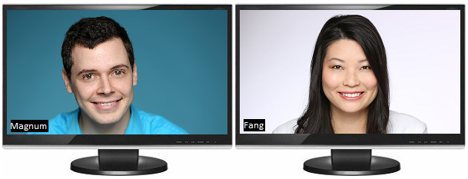.
Telepresence showing webcams when no screen sharing is occurring
Each participant can enable Telepresence by clicking the menu item (three lines icon) then “Preferences” and under “Video” check “Enable Telepresence” and click Save. This change must take place before joining or starting a meeting.
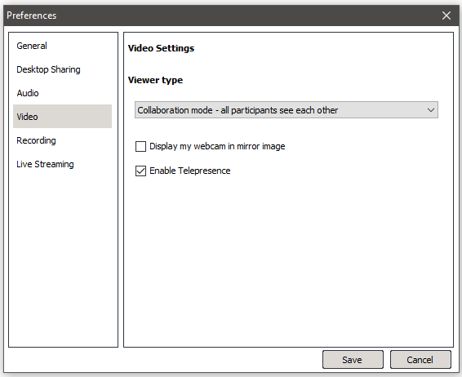

Remote Support
This function simplifies the access to another computer so that you can control and support it. As the host, you can view and control the attendee’s computer as soon as the attendee joins the meeting. In addition, this feature provides a unique remote reboot capability.

Starting a Remote Support Meeting
- Launch TurboMeeting by clicking the TurboMeeting shortcut from the desktop
- Enter the login credentials and Sign In.
- Click the Host icon to host an impromptu support meeting.
- In the next step, choose the Remote Support meeting type.

Inviting the Attendees
Consider a situation where you are facing a problem with your system and want the technician to access your system and solve the problem. In such situations the technician hosts a Remote Support Meeting and invites you to join the meeting.
Another situation could be where more than one person is required to investigate and solve the problem. Consider for instance a case where you and your team leader have to support a computer facing some issue. In such a case, your team leader can initiate a Remote Support Meeting and invite you to support the system facing problems.
By clicking the Invite button, the meeting details can be emailed.

Providing Multi-Tier Support
To join a meeting as a joint-supporter, you need a user account in the TurboMeeting system and you need to follow the steps below.
- Follow the path Start menu (or screen) → Programs (or Apps view) → TurboMeeting → TurboMeeting Start Meeting or double-click the TurboMeeting shortcut from the desktop.
- Enter the login credentials and Sign In.
- In the meeting control panel click the Join meeting icon to join a Remote Support meeting started by someone else.
- There are two different ways in which you can join the meeting.
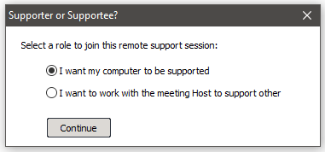
Options to join Remote Support Meeting

- If you choose “I want my computer to be supported” you will have to choose what level of access you want to give to the person supporting you
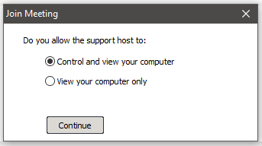
Options to give control to person supporting you (supporter)

Switching to Training Mode
During a support session, you as the host may want to show your screen to the attendee to conduct a training session. You can Change Presenter so that you are the presenter. After the training session, you can change the presenter back to the attendee again.

Rebooting Remote Computer and Auto-Rejoining
There are situations where the attendee is not available at the remote computer throughout the support session. However, the host may have to reboot the attendee’s computer during the support session.

To reboot the attendee computer, the host simply clicks the Reboot button via the floating tool bar (access by hovering your mouse over the little black overlay) and chooses the reboot mode: “Reboot” or “Reboot to Safe Mode”.

The view window of the remote support host

Closing Remote Support Session and Locking Computer
There are situations where the attendee is not available at the system throughout the support session. If the host finishes work on the remote computer, the host can click the Close & Lock button. This will close the remote support session and, as a safety measure, lock the attendee’s computer. The result is that the attendee’s computer will display the Windows Login screen if their computer is running Windows.

Remote Support One-to-One File Transfer
During a support session, you as the host may want to transfer files from your computer to the attendee’s computer, or vice versa. To transfer files, the host clicks the File Transfer button in TurboMeeting. The host then chooses which files and folders to transfer and which direction to transfer the files. For security reasons, a warning message is displayed if the host tries to transfer a file from the attendee’s computer.

The File Transfer dialog allows the supporter to transfer files from mapped drives. And the File Transfer dialog allows supporters to create new folders on remote computers.
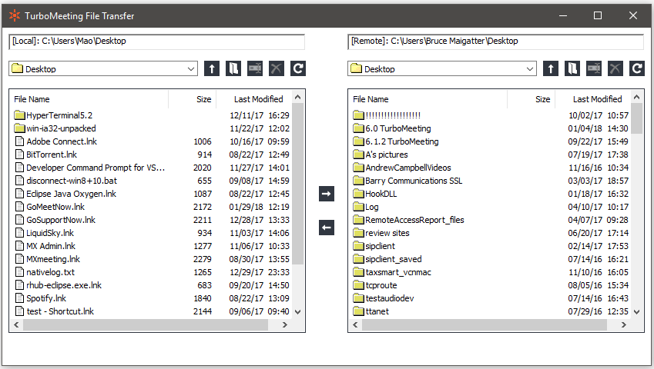
File Transfer window during Remote Support session

Webinars
The Webinar meeting type allows you (as the host) to conduct easy and reliable webinars. Attendees can join the webinar without downloading the TurboMeeting client and view the presenter’s screen using “view-only-mode”. Meanwhile, you can invite a few panelists who must join the webinar interactively. Meeting panelists can become presenters and show their computer screens to all the meeting participants, which is different from view-only attendees.

Attendees do not have the ability to hear the meeting using their computer’s microphone and speakers, which means they must call into the provided audio conference number.

Webinar registration and management pages are provided for you. See our Administration Manual for details on these pages.

Starting a Webinar
- Launch TurboMeeting by clicking the TurboMeeting shortcut from the desktop
- Click the Host icon
- Enter your Email Address, Password and Meeting Server Address and click Sign In.
- Click the Host icon to host an impromptu meeting.
- In the next step, choose the Webinar meeting type.

Inviting Attendees
To invite attendees:
- Click the Invite button.
- Click Email to mail the URL to the invitee or click Copy and paste the URL to the attendees via online messaging tools.

Joining a Webinar
The meeting invite you receive from the host will contain a clickable URL embedded with the meeting ID. Go to the specified URL to join the webinar.
Alternatively, you can go to the meeting server website, click the Join Meeting button and then fill in the Meeting ID, Meeting Password and Your Name to join the webinar.
Attendees must call into the provided audio conference number and specify the access code.

Inviting Meeting Panelists
In the webinar mode, the host can send a clickable link to join the meeting to attendees via email. The attendee who joins the webinar - by clicking the link - can also become an interactive attendee by clicking the Switch to Interactive Meeting button. After the attendee clicks this button, TurboMeeting will start automatically if it is installed or automatically download and get installed and the attendee will automatically join the meeting:

Switching to interactive meeting

The host can assign an interactive attendee to be the presenter. All attendees including the host will be able to see the new presenter’s screen.

Remote Access to This Computer
Using the Remote Access meeting type, you can allow your Windows or Mac computer to be remotely controlled at any time. For example, the host computer (designated as the remote computer) in location A can be controlled by an attendee computer in location B. The Turbomeeting client should be installed in both the computers.

Remote Control
Host (remote computer) at Location A Attendee at Location B

You have to host a remote access meeting in the computer at location A before another computer at location B could access this particular remote computer.

Some of the features of this meeting type are:
- Always on after power recycled: The connection to the remote connection is restored even if there is a power outage at the remote location
- Meeting password encryption cannot be reverse engineered: The meeting password is encrypted superbly; there is no decryption algorithm available to determine this password.
- Auto-reconnection: The TurboMeeting client automatically verifies the connectivity every two seconds. If the connection is dropped for any reason, the client attempts to restore the connection.

Starting a Meeting for Remote Access
Follow the following steps for the computer at Location A:
  - Launch TurboMeeting by clicking the TurboMeeting shortcut from the desktop
  - Click the Host icon and, if asked, enter the login credentials and Sign In.
  - In the next step, choose the Remote Access to This Computer meeting type.
  - Enter the meeting Password. The Password is mandatory.
  - Click Continue. This control panel displays the Attendees and the Meeting ID.

Remotely Accessing my Computer
After you start a Remote Access meeting at Location A, you can now join the meeting from anywhere (Location B) to remotely control the computer at Location A.
- Launch TurboMeeting by clicking the TurboMeeting shortcut from the desktop
- Click the Join a Meeting icon
- Fill in the Meeting ID, Meeting Password, Your Name. In this type of meeting, the Password is mandatory.

Note that you have to remember the meeting password. There is no way to recover the meeting password.
After joining a Remote Access meeting, you can perform the following remote tasks in addition to the remote control and file transfer by pulling down the floating tool bar (hover your mouse over the little black overlay):
- Control the task manager of the remote computer
- Reboot the remote computer

Option to reboot the remote computer

For example, if you click Reboot, the remote computer is rebooted upon confirmation.

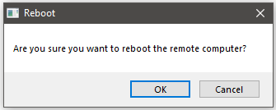

Confirmation for rebooting a remote computer

Note that even if you exit the Turbomeeting application from your computer at location B, the Turbomeeting client will still work on the remote computer at location A. This allows you to access the computer (in location A) from other places and at different times.

You can use the zoom option to Fit-to-screen to fit the screen of the remote computer to the size of your screen. In addition, the zoom option can show the remote computer’s screen as a certain percentage of its original size.

Live Streaming
The Live Streaming meeting type allows you (as the host) to conduct live streams. Attendees can join the webinar without downloading the TurboMeeting client and view the presenter’s screen using “view-only-mode”. Meanwhile, you can invite a few panelists who must join the webinar interactively.

Attendees can only hear the audio from the stream and do not have the ability to call into meeting.

Webinar registration and management pages are provided for you. See our Administration Manual for details on these pages.

Starting a Live Stream
1. Launch TurboMeeting by clicking the TurboMeeting shortcut from the desktop
2. Click the Host icon
3. Enter your Email Address, Password and Meeting Server Address and click Sign In.
4. Click the Host icon to host an impromptu meeting.
5. In the next step, choose the Live Streaming meeting type.

Inviting Attendees
To invite attendees:
6. Click the Invite button.
7. Click Email to mail the URL to the invitee or click Copy and paste the URL to the attendees via online messaging tools.

Joining a Live Stream
The meeting invite you receive from the host will contain a clickable URL embedded with the meeting ID. Go to the specified URL to join the live stream.
Alternatively, you can go to the meeting server website, click the Join Meeting button and then fill in the Meeting ID, Meeting Password and Your Name to join the webinar.

Inviting Meeting Panelists
In the live streaming mode, the host can also invite meeting panelists who will join the meeting via the Turbomeeting application. The panelists join the meeting as an interactive meeting. This feature makes Rhub’s live streaming unique in that the program live streams an interactive meeting. Viewers who join on their browser can see the presenter’s screen and hear all the audio coming from the interactive meeting.

The host can invite panelists by clicking Invite (in the bottom left corner) and selecting the “Invite Panelists” check box.
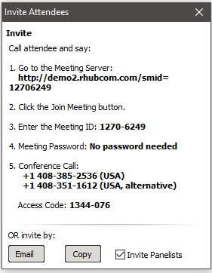

Unattended Support
Unattended Support is a support session that occurs when the supportee, a person with a Windows or Mac computer that is being supported, is not present when their computer is receiving support. An Unattended Support session works exactly the same as a “Remote Access to This Computer” meeting.

To enable an Unattended Support session (or meeting), the supporter first starts a Remote Support meeting.

On the supportee’s system, the supportee clicks the link in the email the supporter sent or goes to the meeting server’s web site, clicks Join Meeting enters the generated meeting id, password and name to join this Remote Support meeting.

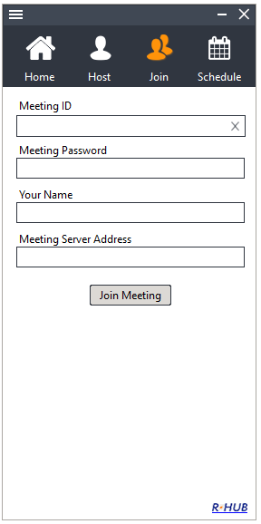
Supportee joins the Remote Support meeting

The supportee should accept the default answers: “I want my computer to be supported” and “Control and view your computer”:

Supportee allows supporter to Control and view your computer

If the supportee is not a Windows Administrator, the “Run as Admin” option appears on the supportee’s TurboMeeting control panel. Click the “Run as Admin” icon and specify a Windows Administrator’s Name and Password for the supportee’s computer:

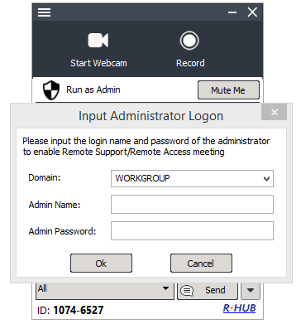
For Windows non-Admin users, specify an admin name and password

If you are specifying a local admin account, it may be best to specify a period for the Domain field: .
On the supporter’s computer, choose Tools | “Change to unattended support session”:

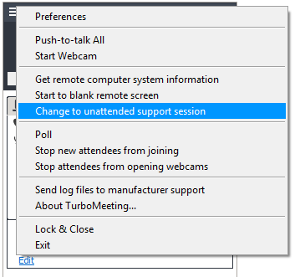
Supporter changes to unattended support session

The supporter must enter a Computer Name for the supportee and a Meeting Password:
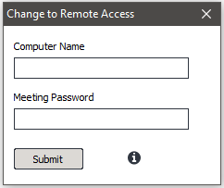
Supporter enters supportee’s computer name and a meeting password
The supportee must accept that the supporter can provide unattended support:

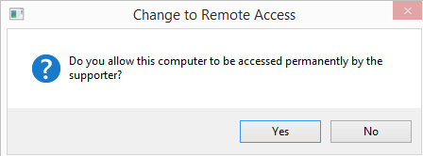
Supportee should accept that the supporter can provide unattended support

This meeting has now become a Remote Access meeting. From now on, the supporter will be able double click the meeting ID to access this meeting from their Active meeting list:
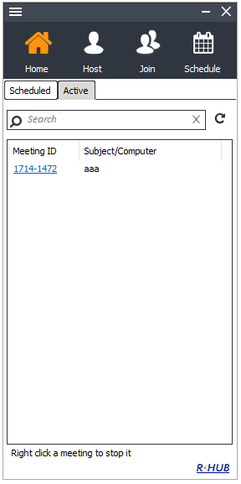
Supporter will always see this Remote Access meeting in their Active list

Scheduling Meetings
There might be instances when you have planned a meeting earlier and want to inform the invitees in advance. In such cases, you can schedule the meeting using the Schedule Meeting option.

Scheduling a Meeting
To schedule a meeting:
- Log into TurboMeeting.
- Click the Schedule icon.
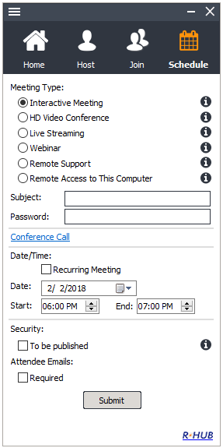
Scheduling meetings
- Select the Meeting Type.
- Enter the Subject of the meeting.
- Enter the password, which is optional for all meeting types except Remote Access to this Computer.
- Select the Date.
- Select the Start and End time.
- Select Recurring Meeting to schedule a recurring meeting. If this option is selected, the Date and Time options are disabled.
- Click Submit.
When you login to TurboMeeting next time, the scheduled meetings and the details are displayed.

Editing a Scheduled Meeting
To edit a scheduled meeting:
- Click the Edit link of the respective meeting.
- Make the necessary modifications.
- Click Submit.

Starting a Scheduled Meeting
To start a scheduled meeting, click the Start link for the respective meeting.

Deleting a Scheduled Meeting
To delete a scheduled meeting, click the More option, then the Delete option for the meeting you would like to delete. Click Yes to the dialog asking if you want to delete the meeting.
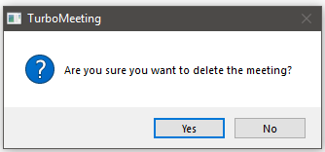

Dialog asking if you want to delete the scheduled meeting

Transfer a Scheduled Meeting to a New Host
Before a meeting starts, the host of a scheduled meeting can transfer the meeting to another host. This is helpful if the original host will not be available to host the meeting. Note that the RHUB system administrator can also transfer a meeting to a new host.
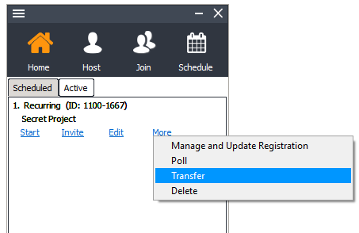

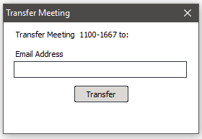
Transfer scheduled meeting to a new host

Managing your Profile
Note that LDAP users cannot edit their profile. Follow these steps to manage your profile:
- Log into TurboMeeting.
- Click the menu item Tools then Edit Profile.
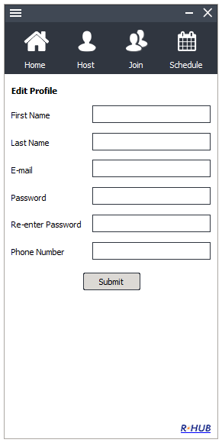
Managing profile
- Edit your First Name, Last Name, and E-Mail.
- Provide a Password and Retype your password to confirm it.
- Specify your Phone Number.
- Click Submit.

Support Contact
If you purchased the TurboMeeting Appliance from a RHUB value-added reseller, please contact them for support. If your reseller is not able to provide you adequate support, your reseller will contact us or you can contact us directly.

RHUB Communications, Inc.
4340 Stevens Creek Blvd.
Suite 282
San Jose, CA 95129
Tel: 408-899-2830 extension 2
Fax: 408-516-9612
support@rhubcom.com
http://www.rhubcom.com

